**1.What goal will your website be designed to achieve?**

My website will be designed to allow users to look up manga, leave reviews of manga, allow the user to mark their latest chapter, keep track of manga they completed and whether or not they liked it.

**2. What kind of users will visit your site?**  **In other words, what is the demographic of your users?**

People that like to read manga and would like a tool to help them keep track of what they’ve read.

**3.** **What data do you plan on using? You may have not picked your actual API yet, which is fine, just outline what kind of data you would like it to contain**.

Using this API:https://anilist.gitbook.io/anilist-apiv2-docs/

I plan on using things like: Title, genre, chapters, staff and their descriptions, media cover images, description of the manga.

**In brief, outline your approach to creating your project (knowing that you may not know everything in advance and that these details might change later). Answer questions like the ones below, but feel free to add more information**:

**a. What does your database schema look like?**

<https://dbdiagram.io/d/6232ff5c0ac038740c4e2472>

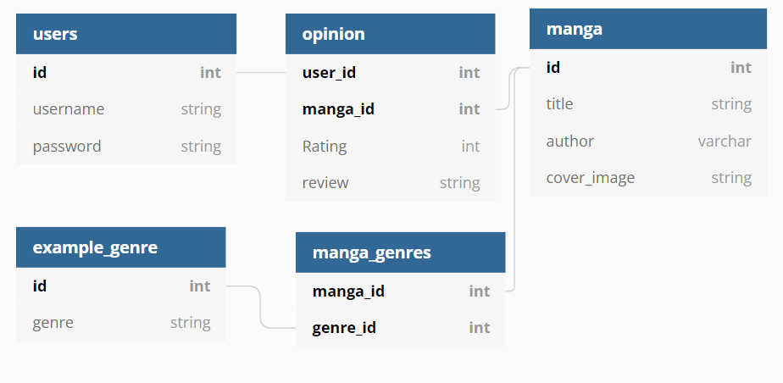

**b. What kinds of issues might you run into with your API?**

There might be issues grabbing the number of chapters for currently updating series, finding the author might be an issue as well because they seem to be listed under the role: story and art rather than author

**c. Is there any sensitive information you need to secure?**

Only passwords

**d. What functionality will your app include?**

The ability to search up manga by title or possibly author, rate it, and review it, and see other ratings and reviews, possibly get recommendations based on genre of author. Allow user to store current chapter as a bookmark

**e What will the user flow look like?**

Users will look up a title in order to see a description of the manga in question. They should be able to see reviews left from other users. From there they can choose to leave an opinion that may include a review, a rating, and a chapter bookmark

**f. What features make your site more than CRUD? Do you have any stretch goals?**

Recommendations of other manga based on genre. My stretch goal would to be to implement a recommendation based on authors